**Please follow this guide to configure outlook express for smartconnexions Email Ids:**

Open Outlook Express and select Tools. Click "**Accounts...**”

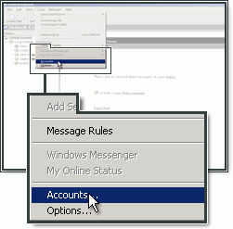

Click "**Add**" and choose "**Mail...**".

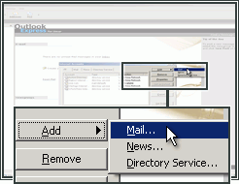

Type your **Name** (*this will be shown when people receive a message from you*).

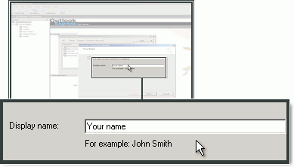

Type the **E-mail address**, created in the control panel, and click "**Next**".

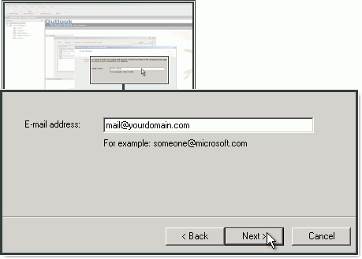

It would be ***EmailIDLogin@smartconnexions.in***

Choose **POP3** as your account type.

In **incoming mail (pop3)**, enter **pop.smartconnexions.in**

For **SMTP server (outgoing server)**, enter **customer-smtp.one.com** and click "**Next**".

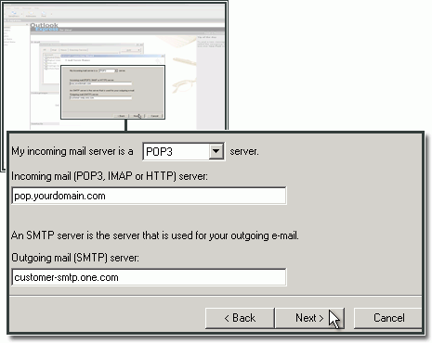

Type the e-mail address (**Eg: EmailID@smartconnexions.in**)and password that you created in the control panel and click "**Next**".

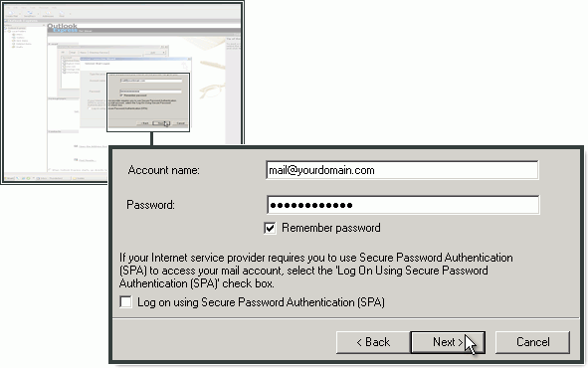

Click "**Finish**" to complete the setup.

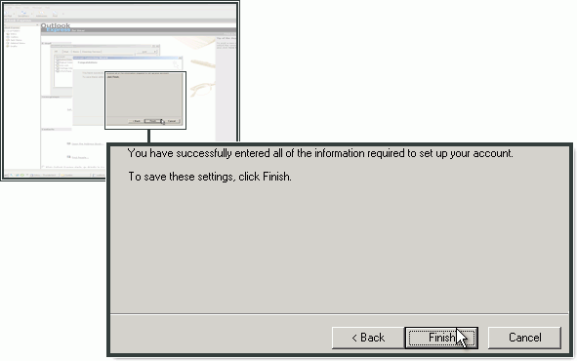

**Configuration of SMTP server in Outlook Express**

Open Accounts panel:

**Tools->Accounts**

Mark the mail account in the list and click "**Properties**".

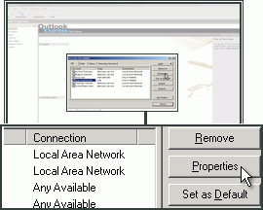

Select the "**Servers**" tab.

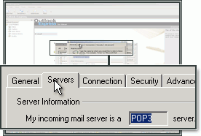

Check "**My server requires authentication**" if it is not already checked.

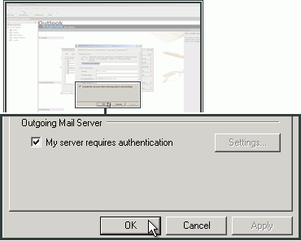

Select the **Advanced** tab.

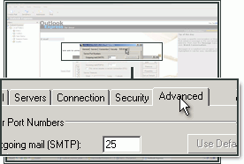

In "**Outgoing server (SMTP)**" enter **2525**.

Click "**OK**".

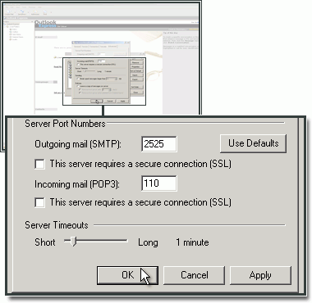

If you find any difficulties, please mail across to:

[info@crea2ive.com](mailto:info@crea2ive.com)

[Razikh@gmail.com](mailto:Razikh@gmail.com)

Regards,  
Crea2ive Team